🚀 STEP 1: Launch First EC2 Instance
Go to:
AWS Console → EC2 → Launch Instance
Configuration:
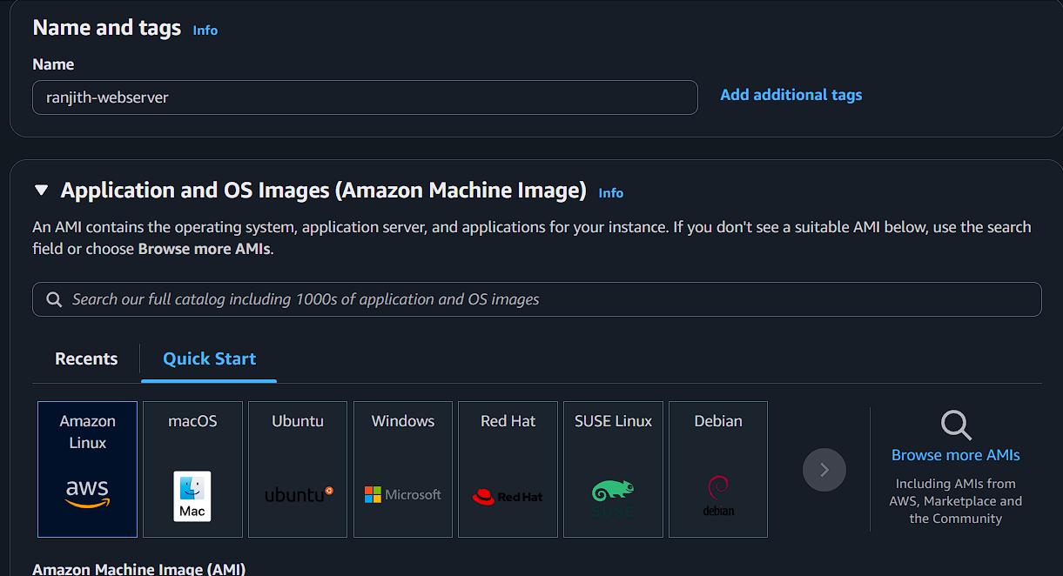

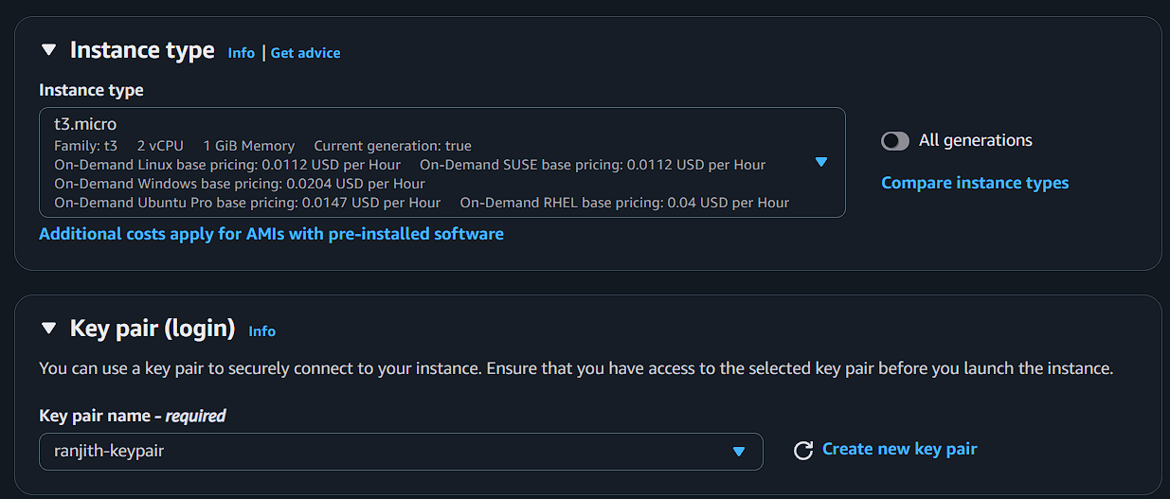

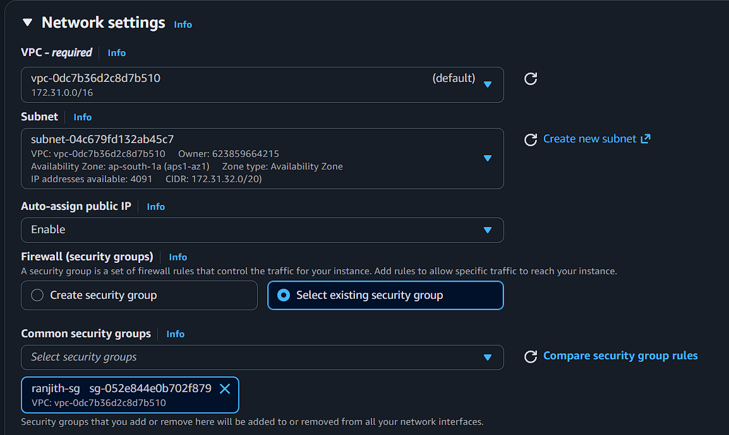

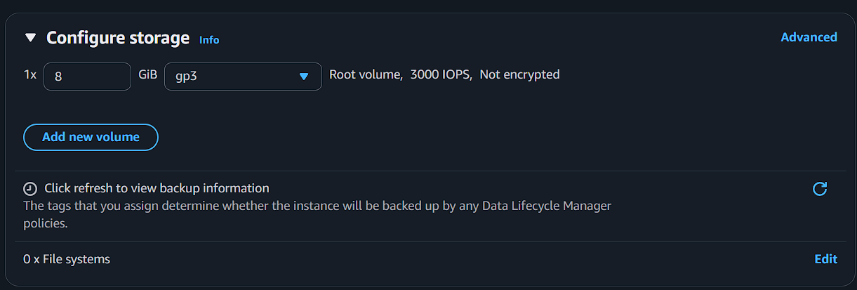
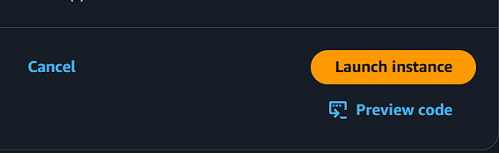

🔹 STEP 2: Install Apache (httpd)
SSH into instance:
ssh -i studentname-key.pem ec2-user@<public-ip>
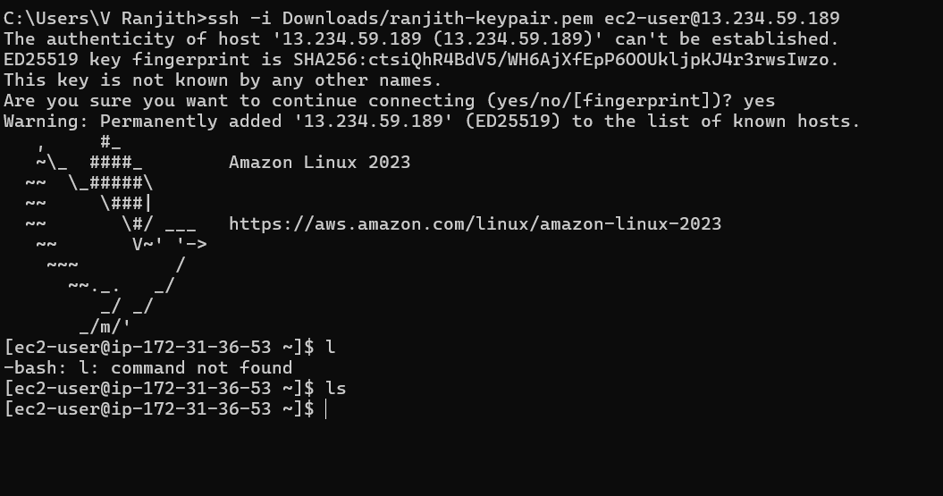

Install httpd:
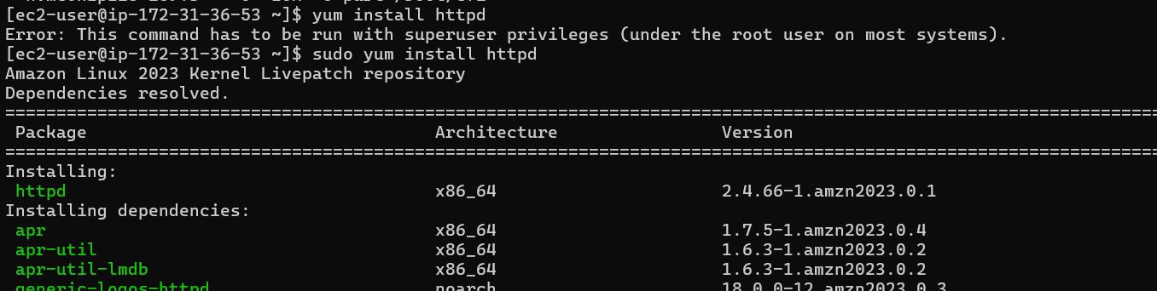

sudo yum update -y
sudo yum install httpd -y
sudo systemctl start httpd
sudo systemctl enable httpd

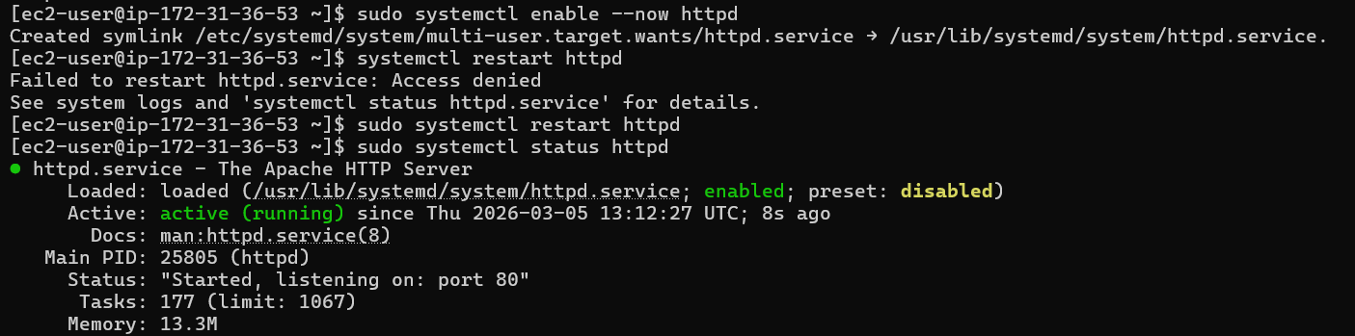

🔹 STEP 3: Create Files and Folders
Create folder:
sudo mkdir /var/www/html/studentname-data
Create HTML file:
sudo vi /var/www/html/index.html
Add:
<h1>Welcome to StudentName EC2 Server</h1>
<p>This server is created from custom AMI lab.</p>
Create another file:
sudo vi /var/www/html/studentname-data/info.html
Add:
<h2>This is custom folder content</h2>
Restart httpd:
sudo systemctl restart httpd

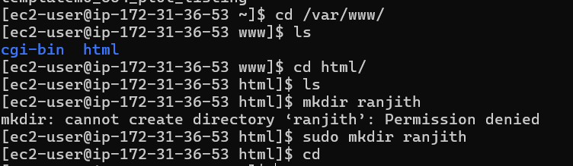
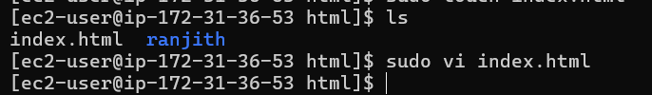

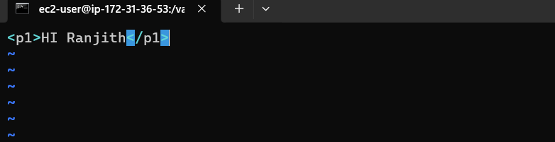

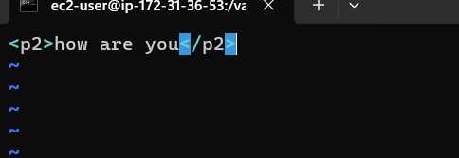
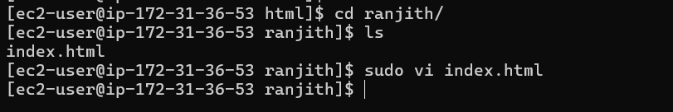
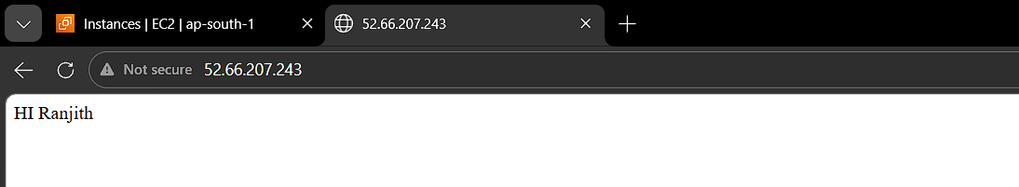

🔹 STEP 4: Validate Website
Open browser:
http://<public-ip>
You should see:
👉 Welcome to StudentName EC2 Server
Check folder:
http://<public-ip>/studentname-data/info.html

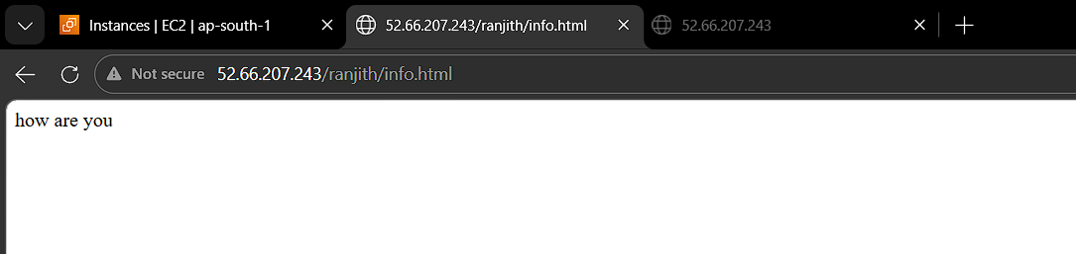

🖼 STEP 5: Create Custom AMI
Go to:
EC2 → Instances → Select studentname-ec2-1
Click:
Actions → Image and Templates → Create Image
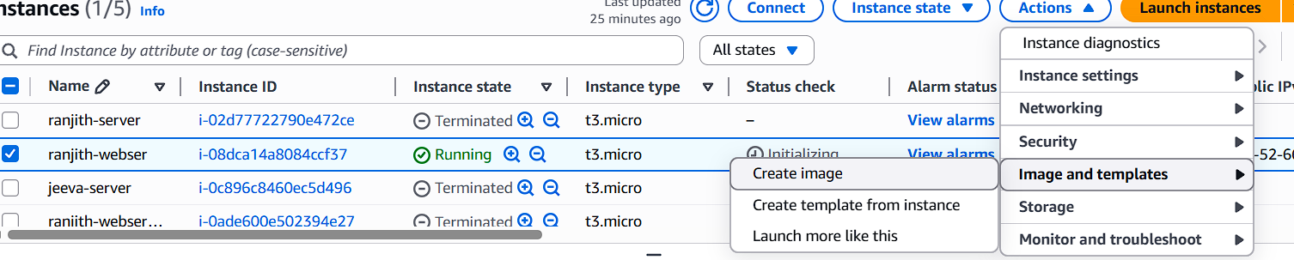
AMI Name:
studentname-custom-ami-v1
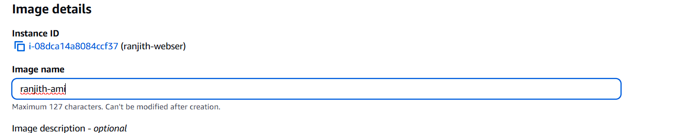

Click Create Image
Wait until AMI state = Available
Go to:
EC2 → AMIs → Check status
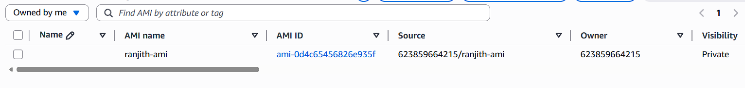

🚀 STEP 6: Launch EC2 From Custom AMI
Go to:
EC2 → AMIs → Select studentname-custom-ami-v1
Click:
Launch Instance from AMI

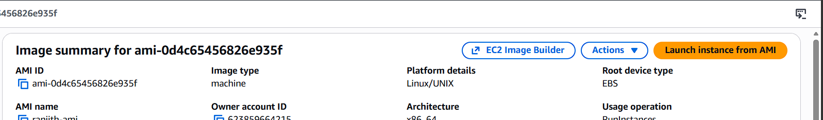

Configuration:
Setting | Value
Name | studentname-ec2-2
Instance Type | t2.micro
Key Pair | studentname-key
Security Group | studentname-sg
Launch instance.
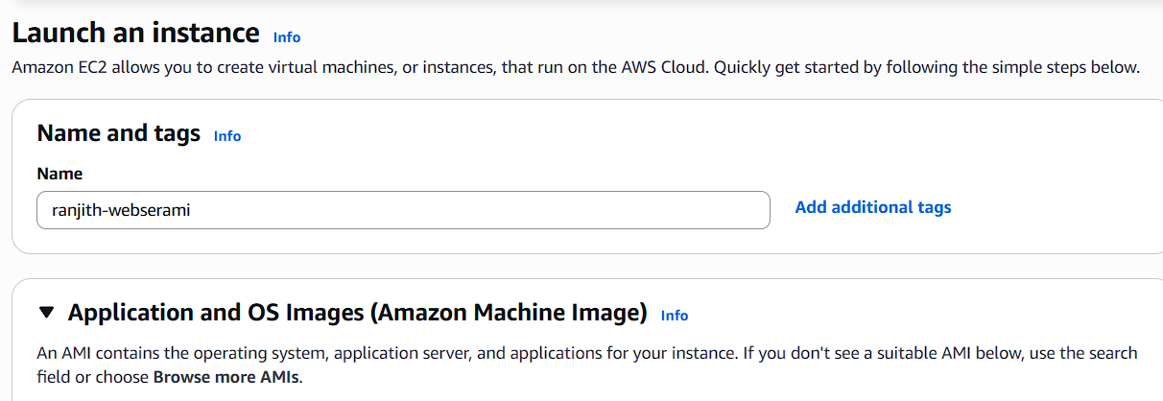

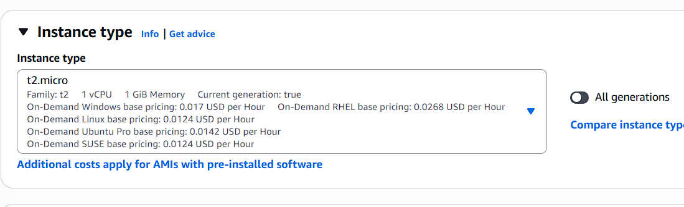

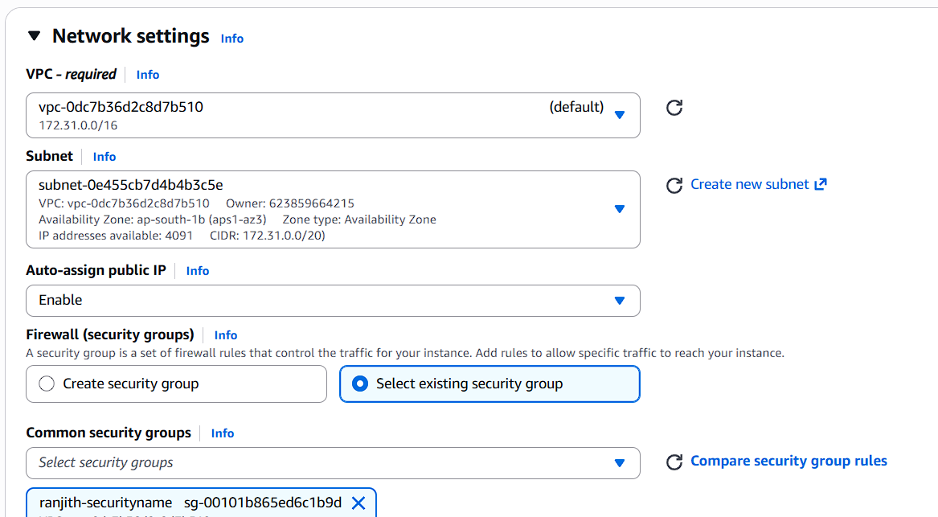

🔎 STEP 7: Validate Second EC2
Open browser:
http://<new-public-ip>
You should see:
✅ Same website ✅ Same folder ✅ httpd already running
👉 This proves AMI captured OS + packages + files.
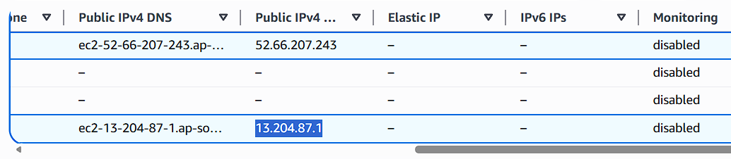

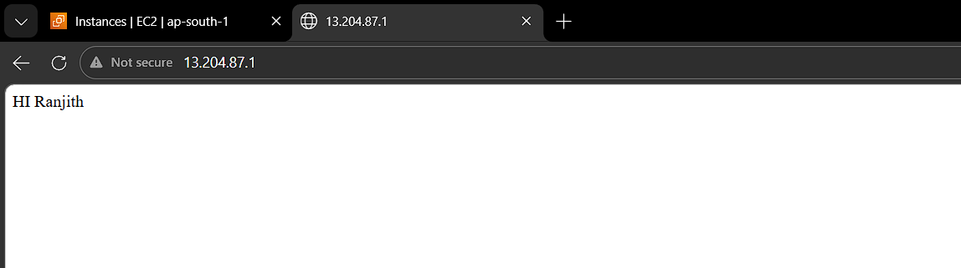

🌍 STEP 8: Copy AMI to Another Region
Example:
From: Mumbai (ap-south-1) To: Singapore (ap-southeast-1)

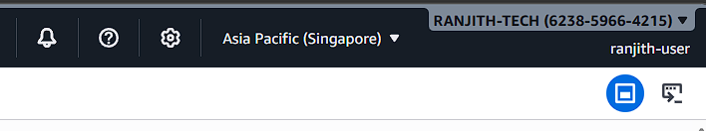
Go to:
EC2 → AMIs Select studentname-custom-ami-v1

Click:
Actions → Copy AMI
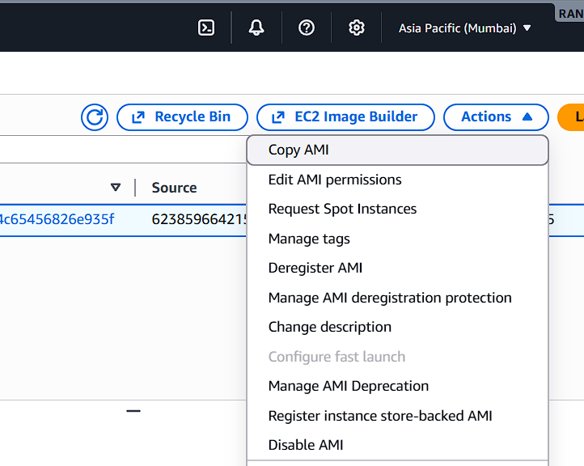
Choose:
Destination Region: Singapore New Name:
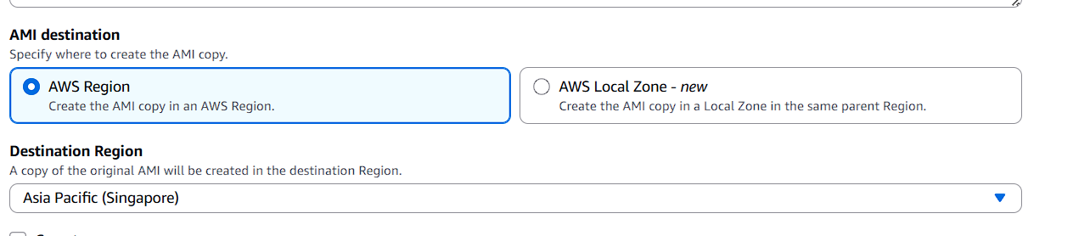

studentname-custom-ami-dr
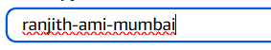
Click Copy

Switch Region (Top Right) → Singapore

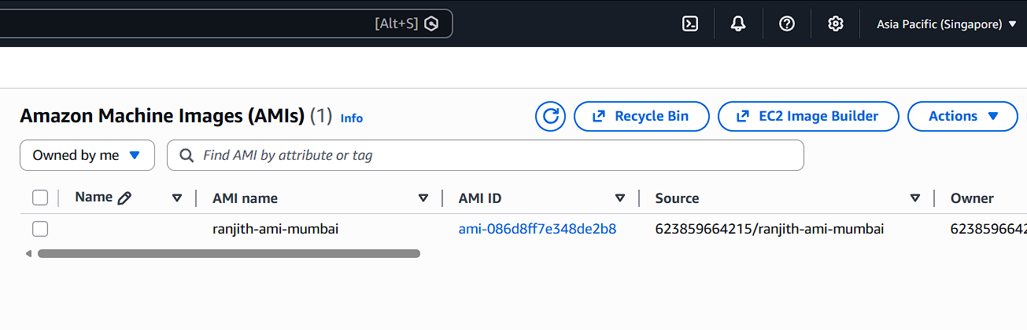
Wait until AMI available.

🚀 STEP 9: Launch EC2 in Another Region
In Singapore region:
EC2 → AMIs Select studentname-custom-ami-dr
Launch instance:
Name:
studentname-ec2-dr
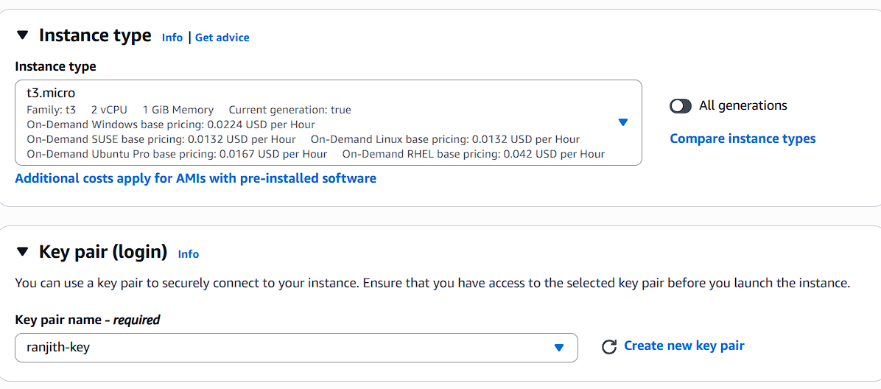
Use new key pair (create if needed for that region).
Launch.

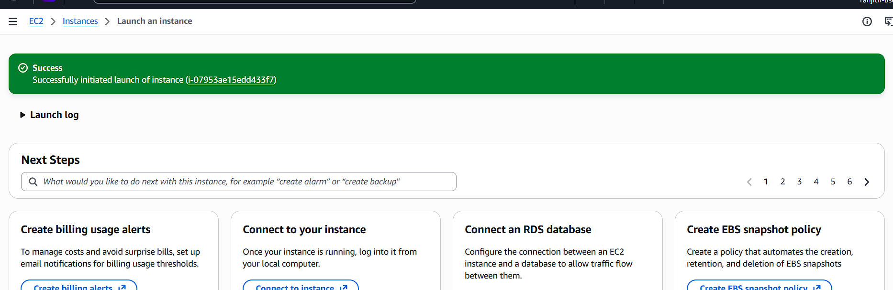

🔎 STEP 10: Final Validation
Open browser:
http://<singapore-public-ip>

